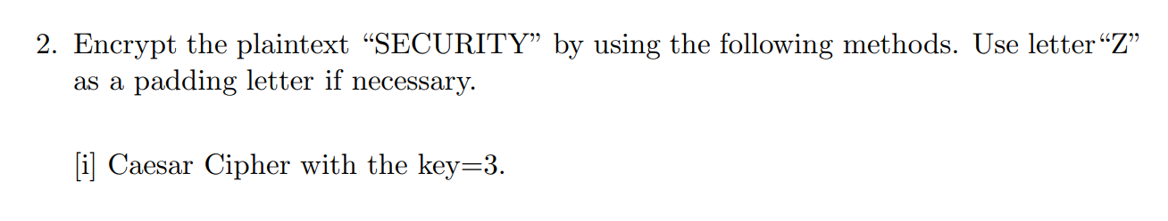

01234567890123456789012345  
ABCDEFGHIJKLMNOPQRSTUVWXYZ

DEFGHIJKLMNOPQRSTUVWXYZABC

**ANSWER**: VHFXULWB